

# OCEANGATE

**Supervisor:** *NGUYỄN HẠ VY*

**Semester:** *01*

**Batch No:** *T1.2208.A2*

**Group No:** *04*

|  |  |  |
| --- | --- | --- |
| **Order:** | **Full name** | **Roll No.** |
| ***1.*** | ***PHAN THE VINH*** | **Student1409151** |
| *2.* | *TRAN RA XIN* | Student1409683 |
| *3.* | *TRAN THANH DAT* | Student1409676 |
| *4.* | *NGUYEN VAN NINH* | Student1409668 |

***Month****: 10* ***Year****: 2022*



This is to certify that

**Mr. PHAN THE VINH Mr. TRAN RA XIN Mr. TRAN THANH ĐAT**

**Mr. NGUYEN VAN NINH**

Have successfully Designed & Developed

# OCEANGATE

Submitted by:

**TRAN RA XIN**

Date Of Issue: 11/23/2022

Authorized Signature:

# Content

Content Acknowledge Synopsis

1. Content  
2. Acknowledge  
3. Synopsis  
4. Review 1  
5. Review 2  
6. Review 3  
7. Testing Document  
8. Task Sheet

# Acknowledge

As we understand that the eProject is a step-by-step learning environment that closely simulates the classroom and Lab-based learning environment into actual implementation. It is a project implementation at your fingertips!! An electronic, live juncture on the machine that allows you to.

* Practice step by step i.e. laddered approach.
* Build a larger more robust application.
* Usage of certain utilities in applications designed by user.
* Single program to unified code leading to a complete application.
* Learn implementation of concepts in a phased manner.
* Enhance skills and add value.
* Work on real-life projects.
* Give a real-life scenario and help to create applications that are more complicated and useful.
* Mentoring through email support.

First of all, I would like to thank India Aptech for allowing my team to work on this fantastic eProject. We had a great experience with eProject this time.

Next, We would like to express my special thanks to our mentor, Ms. Ha Vy for the time and effort that she provided throughout the project. Your helpful advice and suggestions were beneficial to us during the completion of the project. In this respect, We are forever grateful to you.

Besides several mistakes we made in the project, we hope to have more opportunities to widen our knowledge in the web-developing world.

We will try to continue to learn and improve ourselves even more in the future.

Yours Sincerely, Team Group 01.

# Synopsis

The Objective of this program we aim is to give a sample project to work on real- life projects. These applications help us build a larger more robust application.

The objective is not to teach us HTML/JavaScript but to provide us with a real-life scenario and help us create basic applications using the tools.

Hence, we can revise the chapters before we start with the project.

This project is meant for students like us who have completed the module of HTML5. These programs should be done in the Lab sessions with the assistance of the faculty if required.

The website (in this project) is a tool that brings everything in the world to you such as historic monuments information natural knowledge and skill in technology...

It is very essential for us that will have a clear understanding of the subject. We think we should go through the project and solve the assignments as per the requirements given.

And get back [***eprojects@aptech.ac.in***](mailto:eprojects@aptech.ac.in) as the assigned schedule.

## Problem Definition

**Madam’s Boutique** is the leading store of branded and designer clothes for women.

The boutique has tie up with various designers whose collection is on their display.

Also different apparel, accessories collection is also available with the store. The

website must be designed for this boutique showing the collection of clothing of

various brands, designer, unstitched garments. A website needs to be developing for

the boutique which must display all the collection.

The website is to be developed for the Windows Platform using HTML5, JavaScript

and Geolocation. The site should work well in all leading browsers including Chrome,

IE, Firefox etc.

Requirement Specification:

Requirements specification: The Website will be created based on the following requirements. 1) The homepage should be created using a Frame with the right logo

2) The website should display a menu which contains options for a brief introduction of the different products available, the location of the store and any other information if required.

3) The information should be categorized by the brand name of the product like if the User wants to see only Samsung products then he clicks on the Link/button/menu etc. and he will see only those Brand products.

4) When user selects any particular brand, a list of products for that brand will be displayed

5) A brief summary of each product's features must be displayed on the Site along with the product, but detailed Features must be stored in individual Word documents that the User wishes to view as such can be downloaded or viewed.

6) User can also compare different products of different as well as similar brands.

7) There should be a “Contact Us” page which will have the Company Address as follows and a mail address which when clicked will invoke the local mail client from where they can send emails. The Company's address must be displayed using the GeoLocation API (e.g. GoogleMaps).

## Customer Requirements Specifications

### User:

#### input:

* Information on search.
* Data of registered members.
* Feedback to the webmaster.

#### Process:

* Find the searching
* Check the data of registered members.
* Check the feedback of users.

#### Output:

* Result of searching.
* Confirm the data of registered members.
* Confirm the feedback of the users.

### Hardware/ software requirement:

#### Software:

* + Notepad/HTML editor
  + Dreamweaver
  + IE 5.0/ Netscape 6.0

#### Hardware:

* + A minimum computer system that will help you access all the tools in the courses is a Pentium 166 or better
  + 64 Megabytes of RAM or better

|  |  |
| --- | --- |
| **Document Name**:  Architecture and design of the project | **SWD/Form** No.03/ARD/Ver1.0 |
| **Version** 1.0 | **Page 3** |

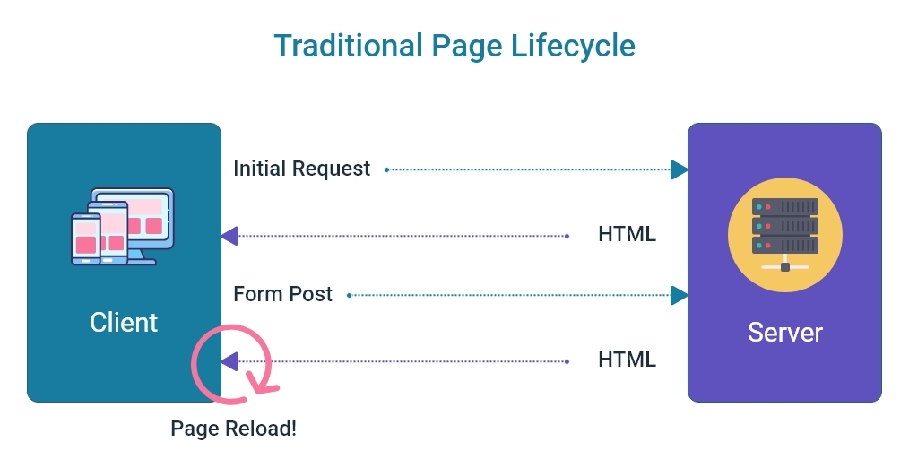

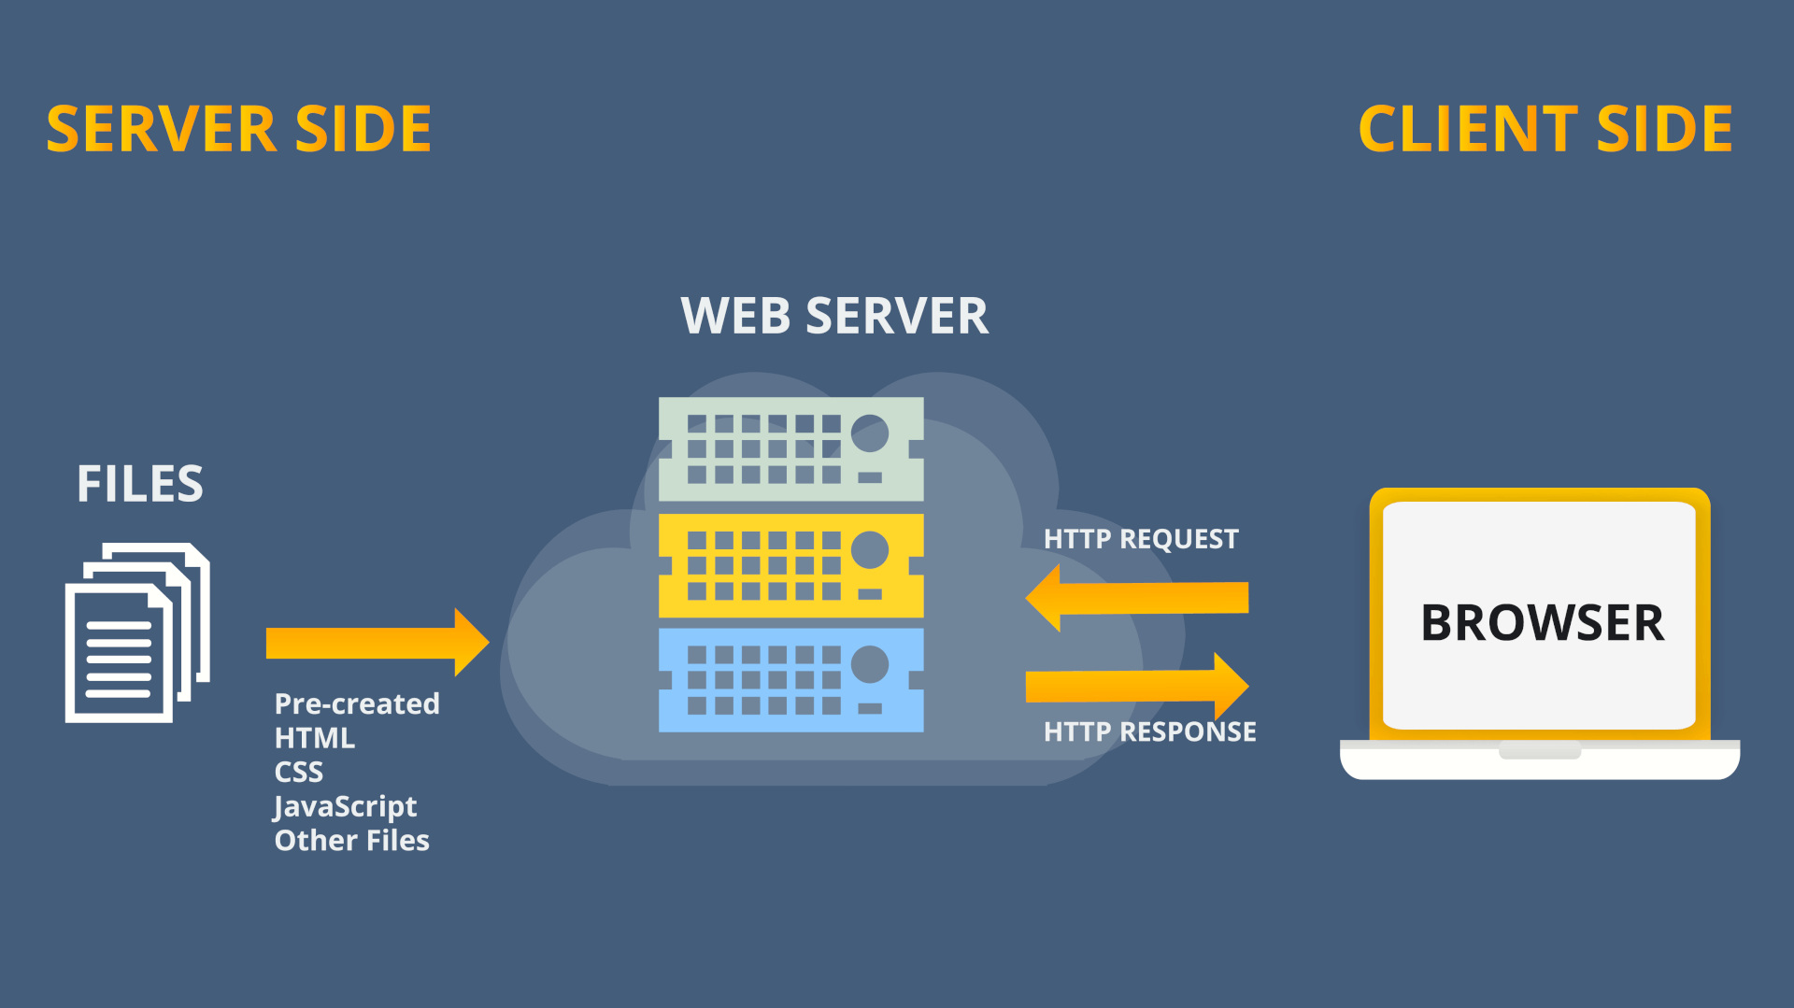

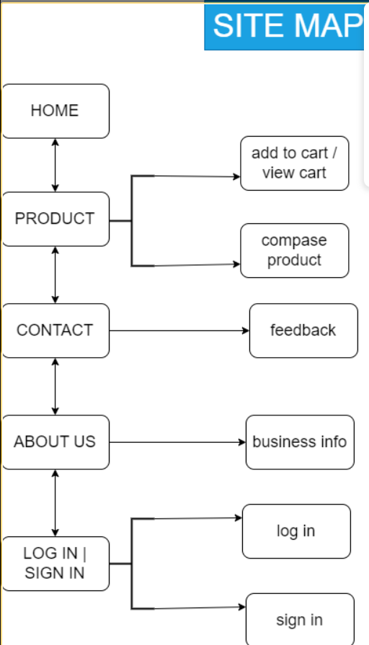

# Open server

***+Windows/MacOS:***

Step 1: Open folder server with link my-shop/server.

Step 2: Right-click -> open Git bash/Open Terminal on VSCode

Step 3: Enter json-server –watch server.json(Note: you can use “cd server”, sure you are at folder server with file server.json in that)

Step 4: When server was created , open file index.html

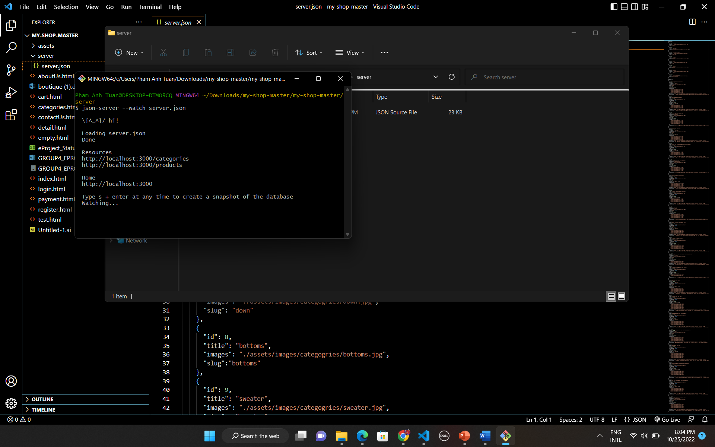

# Screenshots

# I.Homepage

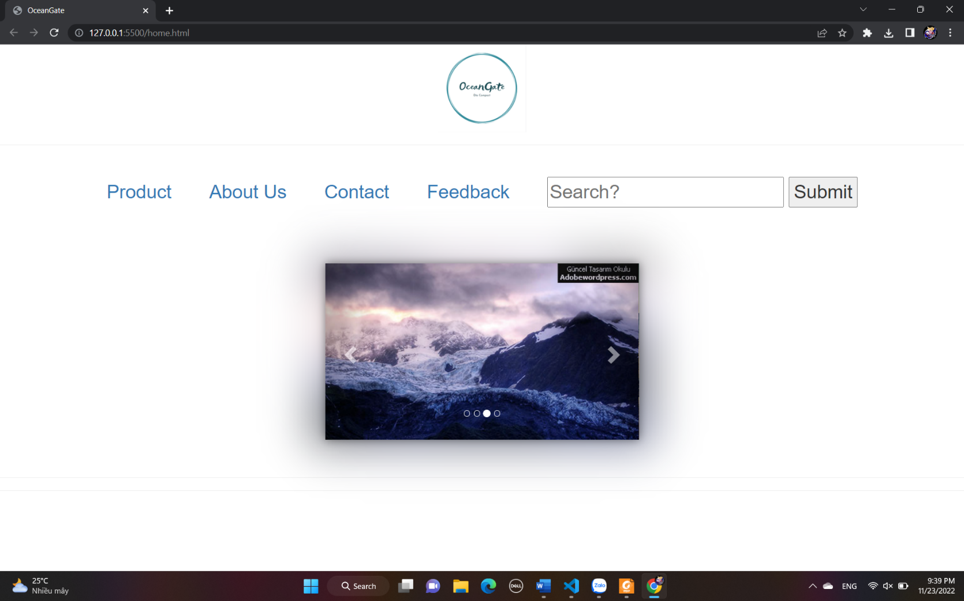

**Overview of Homepage**

**Description Homepage:**

Homepage have:

+Navbar with logo, Product, about us, contact, feedback.

+ Generally I have a search results bar .

+ we have an image carousel .

# II.Product

# + on the product page we have a navigation bar which includes home , products , about us , contact , login , create account , search bar and cart .

# +including product display and purchase areas .

# +The products will be sorted by criteria such as category, rating, ...

# +When purchasing products, they will be processed in cart .

# 

.Overview Product page